Matthew Case
Planning Department
Oxfordshire County Council
Council Hall
New Road
Oxford OX1 1ND

Dear Mr. Case,
I object to the Oxford Flood Alleviation Scheme in its current form on multiple grounds, which are explained below. I believe that we need a flood alleviation scheme, but that it should not involve a two-stage channel.
The scheme raises national-level issues which suggest that it should be decided by a planning inspector or Parliament rather than through a planning application: it would reduce traffic speeds on part of the A34 national trunk road from 60mph to 40mph; it would destroy 1% of the remaining area of nationally-rare MG4a grassland and could lead to the loss of another 5% by drying out the area; it proposes an inappropriate compensation measure for the loss of the heavily-used Seacourt Nature Reserve in contravention of the Acquisition of Land Act 1981; and it is a very poor use of public funds.
There are better alternatives
- The Environment Agency seems to be illogically wedded to the concept of a two-stage channel, even though it is much more destructive and expensive than other options. They have made no significant effort to consider any no-channel, or first-stage-channel-only, or piped alternatives. This goes against the ‘mitigation hierarchy’ required by para. 180 of the NPPF of first avoiding impacts (e.g. no channel), then mitigating (narrower channel) and then compensating (trying to create compensatory sites for destroying MG4a grassland). A ‘no channel’ option would avoid most of the impacts of the proposed scheme.
- It is good practice in environmental impact assessment to assess reasonable alternatives at the same level of detail as the proposed alternative, but the Environment Agency has not done this. Their only attempt at considering no-channel alternatives – Appendix Q of the environmental statement – suggests that a ‘no channel’ option makes much more sense financially than the proposed ‘channel’ alternative (see my points 32-34). The Environment Agency have made no effort to model a pipeline option, although early costings by the Hinksey and Osney Environment Group suggest that this would be much cheaper than the proposed scheme, and would support (rather than substitute for) existing flood alleviation measures.
- Why isn’t the Environment Agency clearing the streams, instead of proposing a destructive and ineffective channel? The streams in the area are impassable because of the number of trees that have come down – see photos below. Clearing these trees and the existing culverts is probably the easiest and most cost-efficient way of reducing flooding.
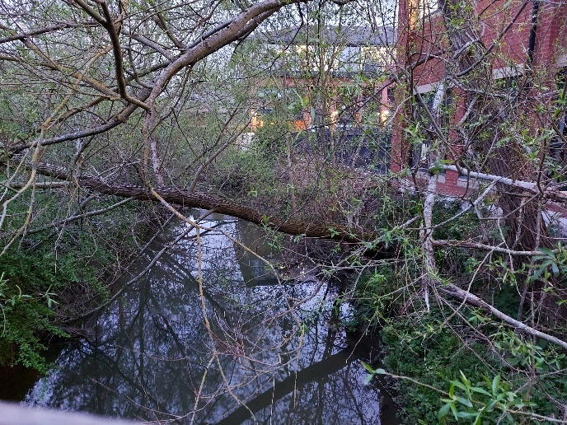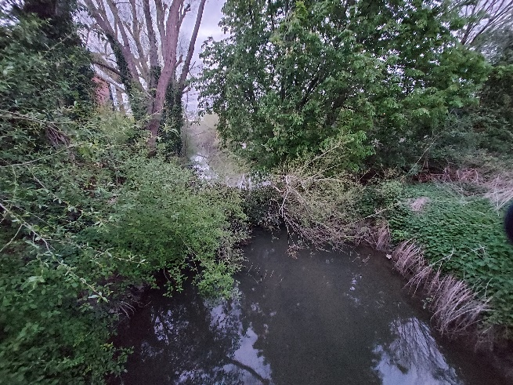

Management
- The environmental statement includes a management plan (Appendix I) but no costings about ongoing maintenance of the scheme. Without such maintenance – mowing, grazing or cutting back of encroaching vegetation – vegetation will accumulate, reducing the effectiveness of the channel over time. The Full Business Case of 2019 does include costings for maintenance, but only for the first 10 years after construction. Subsequent to that “there will continue to be operational funding available to the Environment Agency from government. This is bid for as part of annual maintenance budgets”. Presumably the Environment Agency is also “bidding for maintenance” of the current channels (see photos above)! The costings provided for the proposed scheme are thus too low by 90 years, or else the benefits are too high by 90 years. If 90 years of maintenance were costed for, the benefit-to-cost ratio of the proposed scheme could well fall under 1:1.
Biodiversity
- The proposed scheme would have significant and irreversible impacts on Hinksey Meadow, which is a rare MG4a meadow which requires specific water levels and management. It would destroy 1.33ha of MG4a meadow, and threaten the remaining 7.2-7.7ha of MG4a meadow. There are currently only 194.5ha of MG4a meadow left in England and Wales. Although the Environment Agency proposes to try to replace this loss by sowing seeds from Hinksey Meadow elsewhere, the environmental statement itself states that “This habitat will not fully replace the unimproved grassland lost, because part of its value comes from having been managed in the same way for hundreds of years” (p.182). Essentially this is the loss of an irreplaceable habitat and should be refused, since there are not ‘wholly exceptional’ reasons for taking it forward (NPPF para. 180c, see my points about the ‘no channel’ option).
- The proposed scheme would have significant and irreversible impacts on two Local Wildlife Sites: Hinksey Meadow and Kennington Pit. Policy C7(iii) of the Oxfordshire Minerals and Waste Local Plan notes that “Development shall ensure that no significant harm would be caused to… Local Wildlife Sites… except where the need for and benefits of the development in that location clearly outweigh the harm”. The benefits of a channel are minor – see my points 32-34 – compared to the harm to these sites.
- The scheme would negatively affect the rare creeping marshwort growing in the field south of Willow Walk. (The archaeological works related to the scheme have already meant that horses cannot be grazed in the field, and have indirectly led to the closure of the Old Manor House riding school, a local business). Creeping marshwort is listed as Endangered in the Red Data Book. It is found only in Oxford, and is one of two reasons why Port Meadow is a site of international nature conservation importance.
- The scheme would destroy thousands of mature trees. Although the Environment Agency proposes to ‘replace’ these trees, the lost trees would be mature, whilst the replacements would be whips that will take many years to have equivalent biodiversity, landscape and carbon fixing benefits.
- The scheme would destroy most of the Kendall Copse community woodland, which was planted by local people.
- It would affect protected species. Table 8.5 of the environmental statement concludes: amphibians ‘moderate negative’, bats ‘moderate negative’, otters ‘moderate negative’,
- It seems to struggle to achieve the biodiversity net gain required by the Environment Act 2021, despite the much-vaunted biodiversity benefits of the new wetland habitats. The Environment Agency have not yet responded to a Freedom of Information request about their biodiversity net gain calculations. However the calculations of Sec. 8.4.3 of the environmental statement suggest that a net gain can only be shown if significant assumptions, not consistent with the precautionary principle, are made about replacing existing meadows with MG4 meadows, even though this replacement will be only partially effective at best. Replacement hedges and wet woodlands would have to be provided off site, despite the large size of the area that would be taken up by the scheme.
- Furthermore biodiversity net gain should only be a last resort, after avoidance and mitigation: “It maintains the mitigation hierarchy of avoid impacts first, then mitigate and only compensate as a last resort”. In this case, avoidance is possible by not having a second-stage channel, so the proposed approach is inappropriate, and much/all of the biodiversity net gain should not be needed.
Recreation
- The Environment Agency’s own data show almost 100 people visiting the Seacourt Nature Reserve on an average day in February 2018 (environmental report, p.69) – there will be considerably more visitors post-pandemic, in the summer, and at times when the Environment Agency was not surveying. It is clearly a very heavily-used and much-loved area. The proposed scheme would restrict public access to almost all of this area of publicly-owned and publicly-accessible open space in perpetuity. This is a severe impact.
- The Environment Agency propose to compensate for this loss by making publicly accessible the ‘Jewson Field’ to the south of Jewsons. However the Jewsons Field is already publicly accessible, as evidenced by the Environment Agency’s own surveys of April and August 2019. I had to get these via a Freedom of Information request, and would be happy to share them with you. Below are picture from the unlocked pedestrian gate that goes into the Jewson’s field and the path that runs through the Jewson’s field: clearly people have been using the field for a long time, and nobody is making any effort to stop this. This issue is governed by Section 19 and Schedule 3 Para. 6 of the Acquisition of Land Act 1981, i.e. it is at the level of a planning inspector or Parliament.
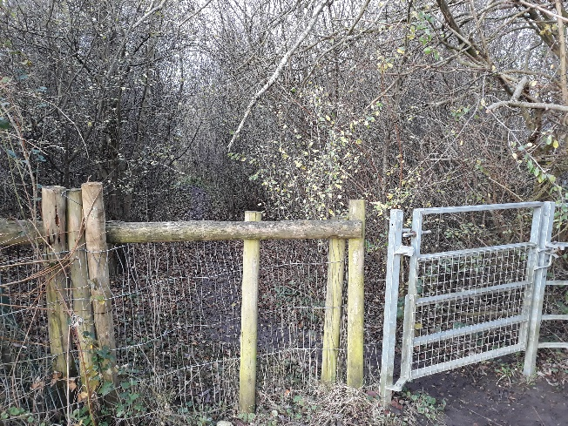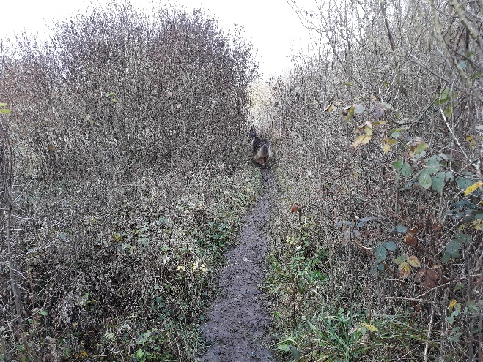
- The scheme would have severe impacts on the wider recreational resource of the area for 3-5 years and beyond. I walk on Hinksey Meadow at least twice a day, and on the fields south from there to South Hinksey and Redbridge on a weekly basis. My, and my neighbours’, recreational access would be severely restricted, and our enjoyment of the area severely affected, during construction: footpaths would be diverted and fields would be replaced by a construction site. Many other local residents would be similarly affected. During operation, fencing around the proposed scheme will continue to restrict recreational access.
Traffic
- The scheme would have severe impacts on traffic. Impacts at the Kennington end would probably be unavoidable in any scenario. However, excavation of the channel would be responsible for the great majority of the average 144 HGV movements/day at South Hinksey, 36 HGV movements/day on the Botley Road, and 14 movements/day at the Abingdon Road. Contractors’ vehicles will add more traffic. The environmental statement does not specify how many non-HGV vehicle journeys will be generated by the scheme, but notes that there will be about 100 construction workers: even with some minibuses or car-sharing, this will involve a significant additional number of vehicles above the almost 200 HGV movements per day… for the scheme’s 3-5 year construction period.
- The traffic from the South Hinksey site is expected to be so bad that the Environment Agency is suggesting a 40mph limit on the A34 between North Hinksey and south of South Hinksey. Essentially, it proposes to significantly reduce the speed limit on a national trunk road so that a limited number of additional houses can be protected by a destructive channel.
Climate change
- Oxfordshire has acknowledged that there is a climate emergency, and its climate action declaration states that Oxfordshire will make climate action a top priority in all decision making. The environmental report states that the proposed scheme will generate almost 20,000 tonnes of carbon over its lifetime, which goes against the aim of having a net-zero carbon Oxfordshire by 2050.
- I put in a Freedom of Information request on 10 April, asking for details of the Environment Agency’s carbon calculations mentioned at Section 14.3 of the environmental statement. I have not yet (3 May) received a response. The environmental statement suggests that the carbon calculations have considered the embodied energy of the scheme, and possibly the equipment used to build it. However it is not clear whether the calculations have included the carbon implications of the removal of several thousand trees, changes to the soil sequestration abilities of the area, and the off-site transport of sand and gravel, all of which would worsen these impacts.
Pollution and health
- Much of the proposed scheme is essentially a linear sand and gravel extraction project. Like any such an extraction project, it would harm the health of people living on North Hinksey Lane, in North Hinksey Village and in South Hinksey through noise, dust, vibrations and air pollution. North Hinksey Lane and South Hinksey residents live within metres of the proposed work: no bunds or other barriers are proposed at North Hinksey Lane, and the houses will look directly down onto the works.
- The A34 at Yarnells Road / Stanley Close is already an Air Quality Management Area because of vehicular NOx emissions, which have been above legal limits since at least 2012. The HGVs and other vehicles associated with the proposed scheme, and particularly the increase in congestion associated with these vehicles, would exacerbate these air quality problems.
- Linked with this are mental and physical health issues. Green infrastructure is linked to physical and mental health benefits. The proposed scheme would significantly reduce local residents’ access to green infrastructure during the 3-5 years of construction, and somewhat reduce access during the operation of the scheme. The scheme is already leading to a lot of stress in terms of concern over what will happen, and would definitely lead to stress due to noise, landscape impacts, reduction in amenity etc.
Landscape and agricultural production
- During construction, open fields would become construction compounds and access tracks. The environmental statement does not show any photomontages for this stage, possibly because they would be too offputting and depressing. During operation, the current landscape would have fewer trees and hedgerows, with easier views of the A34 from the paths through the area. It would be more open and bleak, as shown by the (few) photomontages in Appendix I-8 of the environmental statement.
- The proposed scheme is in the Green Belt. One of the purposes of Green Belts (NPPF para. 138) is to preserve the setting and special character of historic towns. The proposed scheme would absolutely not do this for its 3-5 year construction period.
- The proposed scheme is also in three of Oxford’s view cones: the area is an iconic landscape. The view cones are a means of managing the impact of change on the views of the historic core of the city and its skyline. Again, during construction the scheme would significantly affect views from these view cones, and post-construction the iconic landscape will be changed in perpetuity, with more fencing and fewer trees.
- The scheme will involve disturbance of 100ha of Grade 3b agricultural land during construction, and permanent loss of much of that when operation starts. It will affect local farm businesses. This is at a time when food security and food prices are of considerable concern.
- The proposed bridge at Willow Walk is out of keeping with the setting. The width, surface material and design of the bridge give the appearance of a flyover for use by motor vehicles. As such it is at odds with Willow Walk, which is a cycle and pedestrian route with a rustic character. Part of this comes from the historical association with John Ruskin, whose students helped create the original western section.
Cumulative impacts
Cumulative impacts are the impacts of the proposed scheme plus the impacts of other past, present and likely future activities.
- The A34 is already arguably above capacity at certain times of day, and any accident on the road leads to huge tailbacks. All of this would be worsened by the proposed scheme. The traffic impacts of the scheme would be further exacerbated by construction vehicles related to the large-scale housing developments being built around Oxford. We are aware that the county council is still struggling to establish a transport model that encompasses these new developments: until such a model is available, arguably no additional schemes with significant traffic impacts should be permitted.
- The scheme would destroy 0.7% of the MG4a grassland in England and Wales, and potentially lead to 4.5% more turning into drier MG5 grassland. This is a very significant impact on a rare habitat, which cannot be adequately mitigated.
- The overall impacts of the scheme on South Hinksey would be particularly severe, as the entire village would be surrounded on all sites by a construction compound, access routes and the A34 during the construction period of 3-5 years.
- Several chapters of the environmental statements inappropriately describe the scheme’s impacts in comparison with existing impacts, e.g. additional HGVs represent 0.17% of the 24 hour Average Daily Traffic on the A34; the scheme’s carbon emissions are equivalent to ten days of Oxford emissions. This is an incorrect comparator. The A34 is already extremely busy. Oxford’s emissions are already 718,000 tonnes per year too high. The scheme is adding to all of these impacts, not having an insignificant impact in comparison to them.

Cost-efficiency, fairness
- The great majority of the proposed scheme’s flood protection comes simply from continuing existing maintenance (such as it is) including use of temporary defences: this has a benefit-to-cost ratio of 60:1. A ‘no channel’ option would have a benefit-to-cost ratio of 13:1. Adding a £23 million channel brings this down to 11:1. The incremental benefit of ‘no channel’ is 2.2:1; the incremental benefit of a channel is only 1.4:1, assuming that the Environment Agency manage to stay within the costs assumed by the environmental statement.
- Where a flood scheme reduces the flood risk for a property, this will have the effect of enhancing the property’s value. This is because the risk of flooding is one of the factors that is “priced in” when a property is purchased or leased. Betterment of this sort is a feature of most public works schemes, and is not normally any cause for objection. However, betterment at public expense must be subject to considerations of both value for money and basic fairness. This is especially so where the other (non-financial) costs are spread unevenly. The cost of protecting the additional limited number of properties that the channel would protect is a prohibitive £106,500 - £307,000 per property. The following information comes from Tables 5-7 of Appendix Q of the environmental statement:

Return period | No. residential properties additionally* protected under a ‘with channel’ scenario | No. non-residential properties additionally* protected under a ‘with channel’ scenario | No. residential + non-residential properties additionally* protected under a ’with channel’ scenario | Additional* cost per property protected by a £23 million channel
1 in 50 years | 51 | 24 | 75 | £307,000
1 in 75 years | 54 | 25 | 79 | £291,000
1 in 100 years | 157 | 59 | 216 | £106,500
* additionally to ‘do minimum with temporary defences for 25 years’
- It would be much cheaper to protect the additional properties through other, bespoke means. However this would show up a key problem of the scheme: it is using public funds to protect private property. This may make sense where the benefit-to-cost ratio is high, as a way of “keeping Oxford open for business”. However it makes a lot less sense when talking about a small number of properties whose buyers/owners would probably have known about the flooding problems, and who may have paid considerably less for their property because of this.
- From a national perspective, paying the equivalent of an average house value to protect an average Oxford property from flooding feels daft.
- The environmental statement notes that the scheme will also protect: Botley Road, Abingdon Road, the railway line (at Kennington), and the public utilities. The planning application and environmental statement show a reduced risk of flooding for the roads, railway line and one electric substation, but this is with a “do minimum” scenario. The ES does not state what the protection would be under either of the no-channel options shown as A1 and A2 in Appendix Q. There is no information whatsoever regarding the wider electric supply network, nor fresh water supply or foul water/sewers. This is important because the scheme generates considerable financial and non-financial costs: it is unreasonable for the application to be approved unless the claimed benefits can be confirmed, quantified, and then assessed against the costs.
- Most of the non-financial costs of the scheme in its present form (i.e. with second stage channel) will be split unevenly. Many of those who would experience the benefits live some way from the site of the proposed excavations (for example Osney Island) and so experience few costs. On the other hand those who are more proximate (for example almost all those in North Hinksey east of the A34) will have no benefits but be subject to costs from the nuisances of construction. The same applies to those using the A34 trunk road: no benefits, but costs in the form of delays. Some disparity between individual exposure to costs and benefits is inevitable, but in this instance the scheme seems to address the concerns of a small group, but with no regard to the costs borne by the larger group or by the wider environment.

Yours sincerely,
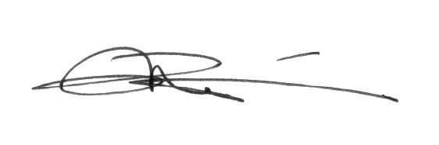
Dr. Riki Therivel

https://www.local.gov.uk/pas/topics/environment/biodiversity-net-gain/biodiversity-net-gain-faqs-frequently-asked-questions
https://www.euro.who.int/__data/assets/pdf_file/0005/321971/Urban-green-spaces-and-health-review-evidence.pdf; https://www.newscientist.com/article/mg24933270-800-green-spaces-arent-just-for-nature-they-boost-our-mental-health-too/

