Initial concerns about the proposed Oxford Flood Alleviation Scheme
with a focus on Area 2, Botley Road to Willow Walk Riki Therivel
All documents referred to here are at https://myeplanning.oxfordshire.gov.uk/Planning/Display/MW.0027/22#undefined.
Traffic
Overall 359,000m3 of materials would be removed from the site; 240 HGV movements per day, plus a construction workforce of 100 (Materials Management Plan 2, p.11)
36 HGV movements/day from Seacourt Park and Ride to the ring road. Temporary loss of 223 parking spaces at the P&R (App M transport assessment, p.32 and p.37).
Biodiversity
No mention of the overall loss of thousands of trees, and associated water retention during floods.
Loss of the willows on the east side of Seacourt Stream, facing North Hinksey Lane (red circles below). Loss of about one-third of the willows on Willow Walk, not replaced (Landscape and Habitat Management Plan Sheet 1 of 7).
Under the Environment Act 2021 the scheme must provide at least 10% biodiversity net gain. But despite the alleged environment-friendly nature of the scheme, it only provides the net gain if:
- Approx. 9.2ha of wet woodland is created off-site
- 4-5km of hedges are planted off-site
- Approx. 730m of ditches are provided off-site (Environmental Statement App. S Biodiversity Metric, pp. 5-7)
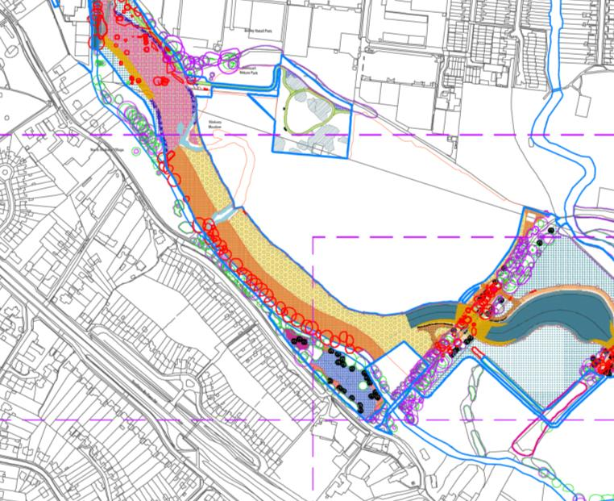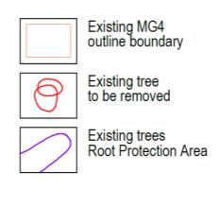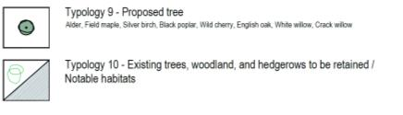
The biodiversity net gain calculations do not include the 1.33ha of MG4 grassland! This is assessed separately because of the importance of the habitat.
“Hinksey Meadow is towards the dry end of the tolerance of MG4 grassland and therefore the potential concern would be any changes that left the ground drier during early to mid- summer during the growing season... There is a high chance that [translocation of the 1.33ha of grassland] will not succeed.” (MG4 Grassland Mitigation Strategy, pp.6 and 8).
Instead, the proposal is to create 17.8a of new MG4-type floodplain meadow on areas shown in yellow below. The field to the SE of Osney Mead has been managed for years as good quality semi- improved grassland, but would be dug up (or scarified to create 50% bare earth) and seeded with green hay taken from Hinksey Meadow.
Signs of otters have been found at Seacourt Stream (besides the N boundary of Seacourt P&R), Bulstake Stream, and at the end of Henry Road (ES App D19 p.7, also two other otter surveys). Construction impacts on the otters are felt to be low “as otters are a mobile species and can avoid the Scheme area during disturbing activites and best practice safeguards should minimise any adverse impacts on availability of fish” (Environmental Statement, p.163).
Impacts on badgers at Kennington are assessed, but not on badgers that use (and may live at) Seacourt Nature Reserve / Jewsons Field.
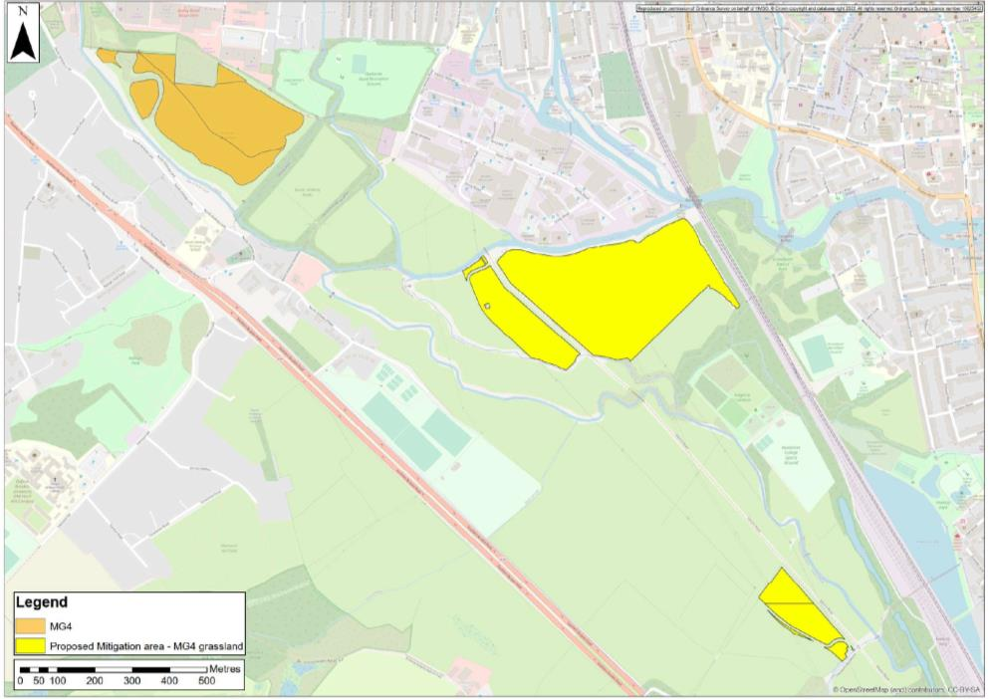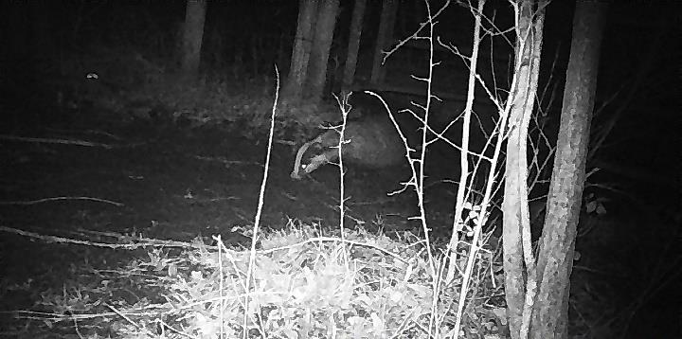
Recreation and access
The Seacourt Nature Reserve will be closed during the duration of construction with a footpath along the edge of the construction working area. 2.4 ha of the ‘heavily used’ Seacourt Nature Reserve will be permanently lost (Environmental Statement, pp.79, 81, 84)
The land behind Jewsons looks like it is being used to compensate for this loss (marked as ‘exchange land area’ in General Scheme Overview). The land is already publicly accessible, so should not compensate for loss of public accessibility of Seacourt Nature Reserve.
Accessibility to the rest of the scheme area will be restricted during operation because the area will be wetter (ES, p.81).
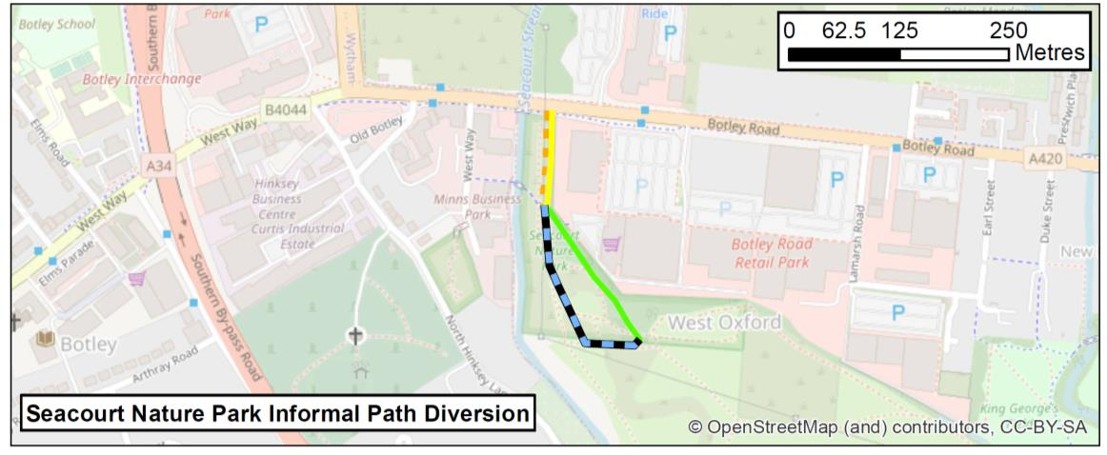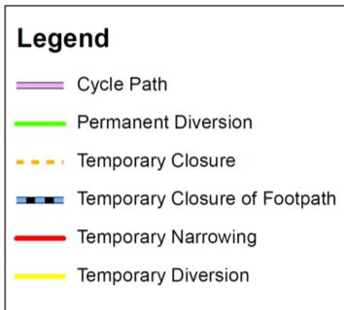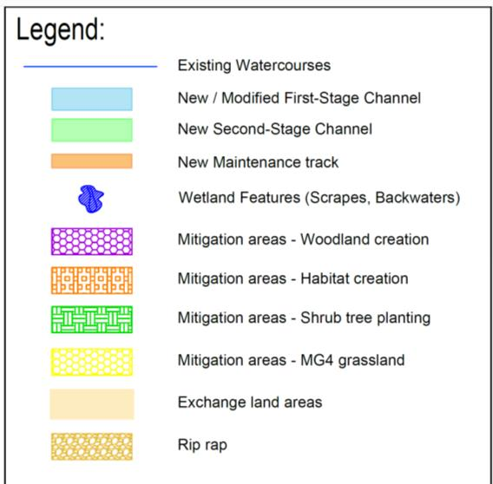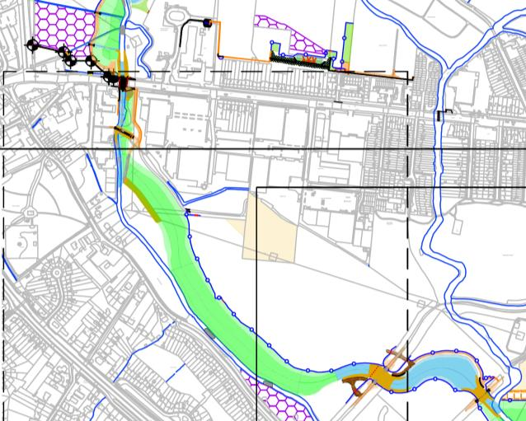
Landscape and visual
The ‘baseline’ visual assessment of Seacourt Nature Reserve was done on a day when there were cars and temporary fencing, and so is a very biased (unnecessarily negative) comparator for the future proposed view (Environmental Statement App I-8, p.5):
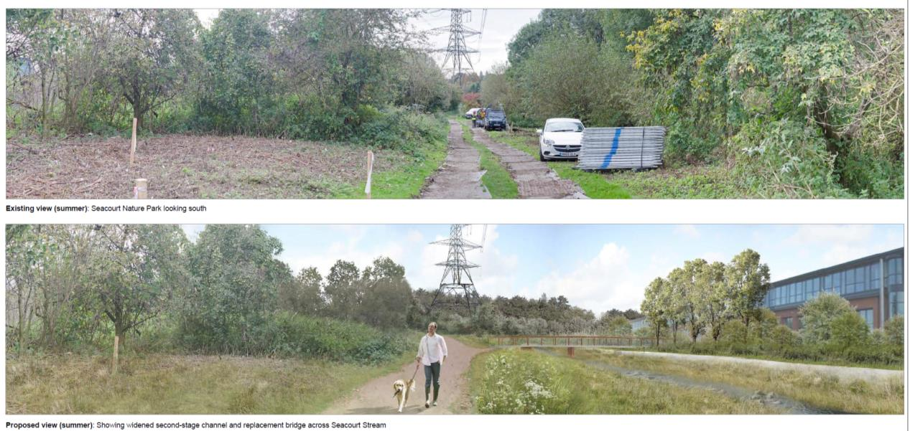
The bridge at Willow Walk would be monstrously large and seemingly paved (Environmental Statement App I-8, p.14):
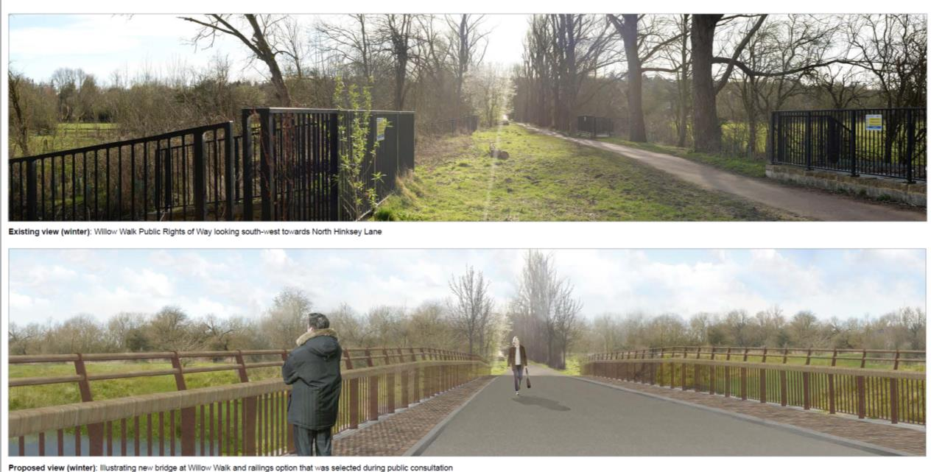
Carbon emissions
Like transport movements, the carbon emissions of the scheme are compared against current emissions. We are trying to get ALL emissions down: “The whole life carbon dioxide emissions over the project life is estimated at 19,558 tonnes and the operational carbon is 4.65% of this (i.e. 909 tonnes) based on the proposed maintenance regime. For comparison, a 2019 Oxford City Council
report stated that direct and (selected) indirect carbon dioxide emissions from the city in 2017/18 were 718,362 tonnes per year. The emissions due to the Scheme including operation for 100 years would be equivalent to direct emissions from the city for ten days.” (Environmental Statement, p.271).

Alternatives
Local residents have proposed several alternatives to the scheme, including pumping the water through underground pipes, and keeping all elements of the scheme except the channel. The ES dismisses the pumped option:
“The twin pipe pumped option would involve the construction of a large underground pump house north of Botley Road and the installation of two large pipes running from this point under the western floodplain discharging in the Redbridge area. This is similar to the culvert option which was discounted at strategy stage due to costs, risk and our policy against culverting if possible. In addition, the Environment Agency, wherever possible promotes passive solutions that operate automatically in a flood event requiring no human intervention or mechanised operation. This removes a significant risk that the intervention needed for non-passive schemes is unavailable when needed, access to equipment isn’t possible due to the wider effects of flooding or the mechanised equipment fails to operate when needed.” (ES, p.19).
The ’no channel’ option is considered at Appendix Q to the Environmental Statement. This models and costs two alternatives to the scheme:
- A1. Proposed channel etc. only from Willow Walk south (not through Hinksey Meadow) but other elements kept
- A2. No channel at all but other elements kept
The appendix provides information about the cost and flood protection of both of these alternatives.
BCR = Benefit-cost ratio; iBCR = incremental benefit-cost ratio, NPV = net present value
The ‘incremental value’ (iBCR) of a scheme must be above 1 to be worth building. In economic terms, not having a channel (iBCR) makes much more sense than having one, and having no channel through Hinksey Meadow makes as much sense as the proposed scheme. This assumes that the proposed scheme costs ‘only’ £122M: previous assessments have put it at £154 million.
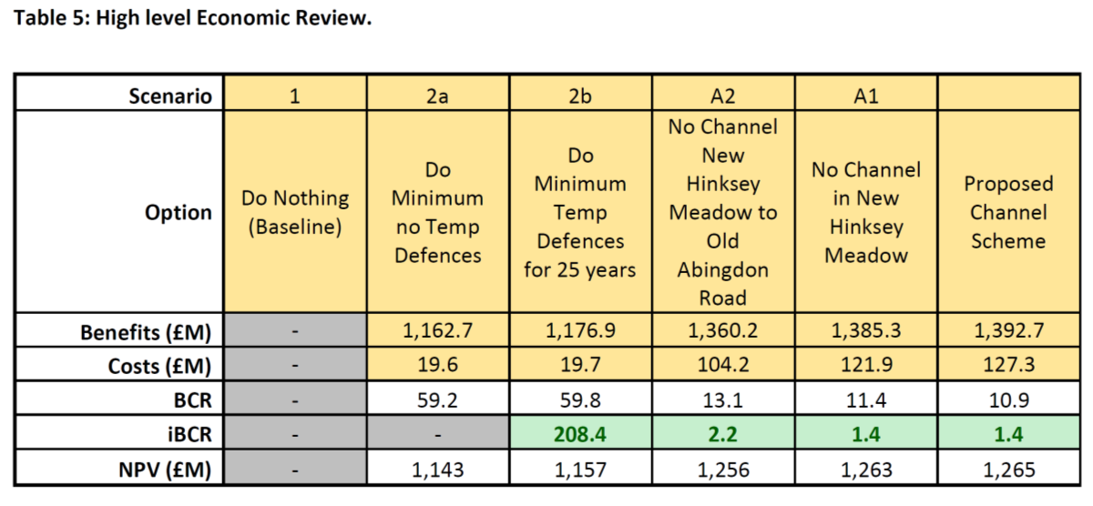
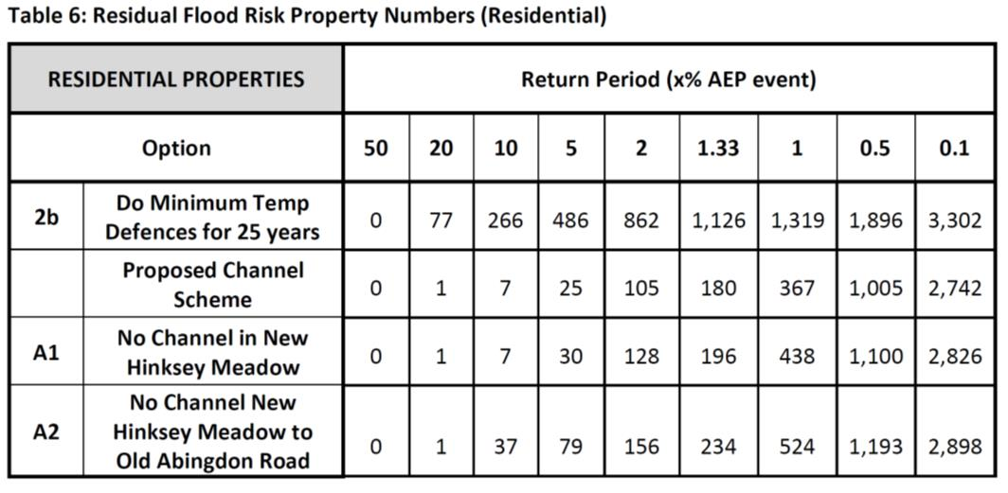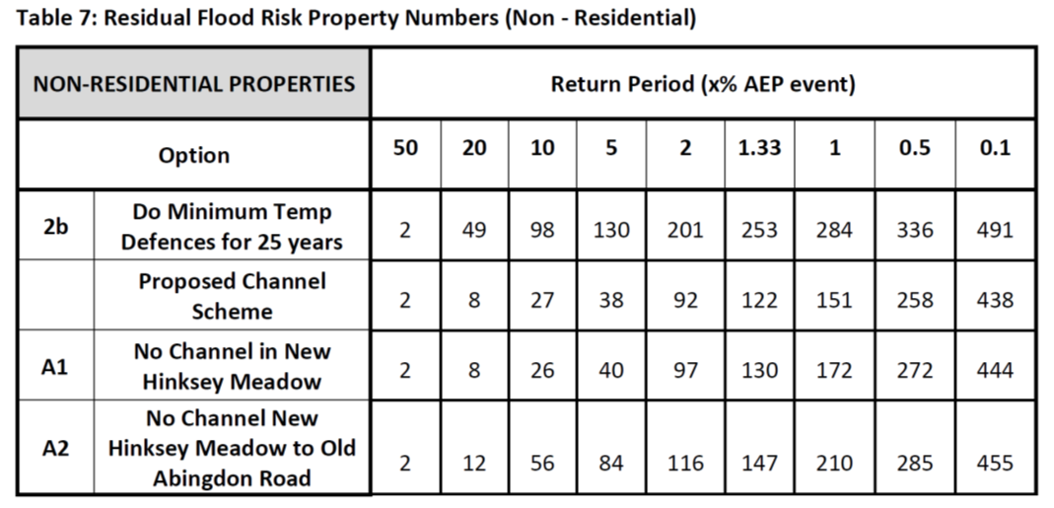
In terms of flood protection, during a 1-in-100 year (1% AEP) flood:
- the full proposed scheme would protect 952 homes (1085 properties) more than ‘do minimum’;
- the scheme without a channel in Hinksey Meadow, protecting the rare MG4 grassland and reducing the scheme cost by £5.4 million, would protect 881 homes (993 properties) more than ‘do minimum’; and
- avoiding most of the channel, with all attendant transport, biodiversity and recreational impacts and reducing the scheme cost by £23 million, would protect 795 homes (869 properties) more than ‘do minimum’.
The Environmental Statement (App Q, pp. 17-21) notes that, without a channel, debris may build up against fencing or hedging, slowing down the water flow and potentially leading to higher flood levels in the area. The same problem applies to the proposed scheme, but to a lesser degree.

